**CBA Exercise -Unit Test Scripts**

**Find Duplicate Files in a Directory**

**Author:Lavanya Soundarrajan**

|  |  |
| --- | --- |
| Document Version: | 0.1 |
| Status: | Final |
| Date | 25/08/2018 |

Contents

1 Document Administration 3

**1.1 Revision History 3**

**1.2 Document Purpose 3**

2 Find duplicate files in a directory 4

**2.1.1 Description 4**

**2.1.2 Test Setup 4**

**2.1.3 Test Script 5**

# Document Administration

## Revision History

This document has the following versions:

|  |  |  |  |
| --- | --- | --- | --- |
| Revision Date | Version No. | Description | Author |
| 25/08/2018 | 0.1 | Document Creation. | Lavanya Soundarrajan |

## Document Purpose

The purpose of the document is to provide the test scripts for the **CBA Exercise – Find duplicate files in a directory.**

# Find duplicate files in a directory

### **Description**

This test script is to test a program which takes a directory as its argument and lists the files which are redundant/duplicate and could be deleted.

### **Test Setup**

1. Use any standard computer machine and create a directory(main directory) and few subdirectories within the main directory as shown below.

|  |  |  |
| --- | --- | --- |
| **Directory Name(Main Directory)** | **Sub Directory 1** | **Sub Directory 2** |
| myfiles | new | new1 |
| myfiles | old | old1 |
|  |  |  |

1. Create test files within the above created main and sub directories as shown below.

|  |  |
| --- | --- |
| **File Name** | **Target Folder Location** |
| timetable.xlsx | myfiles/new/ timetable.xlsx |
| expenses.docx | myfiles/new/ expenses.docx |
| expenses.bk1 | myfiles/old/ expenses.bk1 |
| timetable.xlsx | myfiles/old/ timetable.xlsx |
| expenses.bk2 | myfiles/new1/ expenses.bk2 |
| income.bk35 | myfiles/new1/ income.bk35 |
| income.bak | myfiles/old1/ income.bak |
| users.txt | myfiles/users.txt |
| users.bak | myfiles/users.bak |

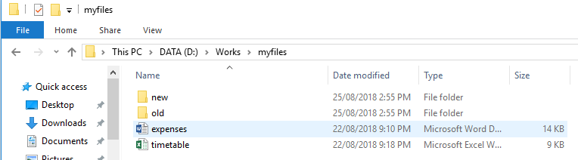

1. Modify the above created files present in the main directory and sub directories,this step is to make sure that the files are modified in different timings for testing the scenario.

### **Test Script**

|  |  |  |
| --- | --- | --- |
| **Step** | **Description** | **Expected Results** |
| 1. | Download the git bundle file **cba-exercise.bundle** to a computer that have python installed already. | File download is successful. |
| 2. | Create a local git repository folder and move the abovedownloaded **cba-exercise.bundle** file in to the folder. | Git repository created successfully. |
| 3 | Go to command prompt and navigate to the above git repository folder. |  |
| 5 | Use "**git bundle verify cba-exercise.bundle**" command to verify the git bundle file | Bundle verified successfully. |
| 6 | Use "**git clone cba-exercise.bundle**" to extract the bundle content to the current directory | Bundle contents are extracted successfully. |
| 7 | Use "**python find_superseded.py**" <path of your test data > to execute the python program file .  *Example :* ***python find_superseded.py D:\works*** | Program outputs the duplicate files.  ***Example : D:\works\myfiles\timetable.xlsx may be superseded by D:\works\myfiles\new\timetable.xlsx*** |